Sanctuary Performing Arts in Hebron to Host Elisabeth Von Trapp in Concert
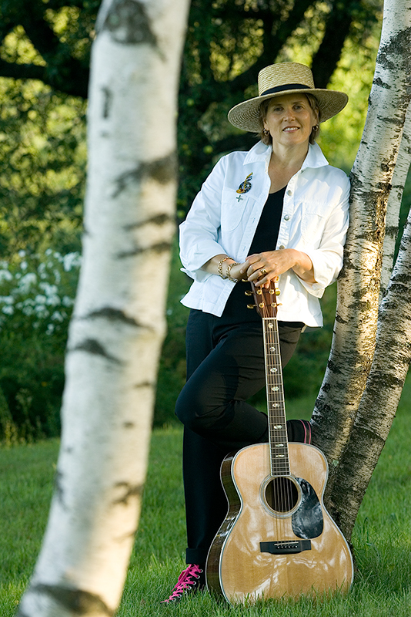
For Elisabeth Von Trapp, granddaughter of the legendary Maria and Baron von Trapp, “ the sounds of music “ are part of her earliest memories. Whether they were from the baroque instruments and four-part harmonies of the family choir, the legendary Trapp Family Singers, a classical symphony on the turntable, or songs played on the diverse collection of musical instruments in the living room; piano, cello, guitars, ukulele, accordion, recorders, dulcimer or zither, music was always present. Inspired by her father's guitar playing and singing, Elisabeth began taking piano lessons when she was eight.
By sixteen she was playing guitar and traveling the back roads of New England performing with her siblings at weddings and gospel meetings, town halls and county fairs. Music has influenced Elisabeth and it was music that made her family name a Hollywood legend. Growing up she heard the sounds of Beethoven, Bach, Vivaldi and Mozart from her father’s record collection and the voices of The Beatles, Dylan, and Joni Mitchell and the Rolling Stones from the open airways of Vermont radio. “Cold winter nights ... I would sit on my bed in the dark, picking out a Join Mitchell song on my guitar as the sounds of Tchaikovsky’s Violin Concerto on the phonograph would float up the stairs from the living room below where my mother sat knitting. Some of my earliest memories are of music.... it has had an impact on me and continues to guide me; music has given me a place to be.”
Elisabeth’s voice has been heard from the subway platforms of New York City and small folk clubs and concert halls to the White House, National Cathedral, and the Kennedy Center. She has released five self-produced albums and her music has been featured on BBC-Radio, Japanese National Radio and CNN Spanish Radio. She has appeared on CBS’s Eye on People, ABC’s Good Morning America and BBC-TV. Describing her unique musical approach, The Chicago Tribune says that “Elisabeth von Trapp sings with an astonishing clarity about disappointment, the power of love and coming of age.”
She will perform in concert at the end of the Harvest Moon Festival at St. Peter’s Episcopal Church, 30 Church Street, Hebron, CT on Saturday, October 26, 2024 at 7:00p.m. as part of the Sanctuary Performing Arts 2024 Concert Series. It will be a full house so come early. Goodwill offerings will be appreciated.

